The battle over property tax elimination rages on in Pennsylvania. The unfortunate but predictable side is that there is much misinformation that continues to be spread about HB/SB 76, the “Property Tax Independence Act”, despite the fact that the bill has been around for years. Some of the misinformation is born from lack of understanding the bill, the rumor mill, and half truths. However, there is also a dark side to this battle, a well planned and orchestrated intentional negative propaganda campaign with regard to the bill.
With November elections nearing the propaganda campaigns have taken on an even more heinous overtone because former Senator and gubernatorial candidate Scott Wagner supports and is campaigning on elimination. Big money behind protecting the school funding status quo is flowing freely. It is well known that the most powerful lobbyist group in Harrisburg is the PSEA. I have been told by my local legislators that generally what they want, they get. They are the ring leaders protecting the status quo. Sadly, if organizations like the PSEA understood the post enactment short term and long term impacts, we are confident they would back the bill.
With that being stated, we shall focus on the many positives of implementing HB/SB 76, the “Property Tax Independence Act”, but from a perspective many rarely hear or consider. For those who are aware of the bill, most understand it is a guaranteed dollar for dollar tax shift from property owners to Sales and Use Tax (SUT) and Personal Income Tax (PIT) that would be used to fund our schools. SUT would increase from 6% to 7% with a slightly expanded tax base. Please note that Pennsylvania has one of the narrowest SUT bases in the nation. PIT would increase from 3.07% to 4.95%. Despite what you may have been told, the vast majority will be financially better off if HB/SB 76 is enacted. That is a big statement to make so let’s explore this. We like to refer to the plethora of positive impacts of a post HB/SB 76 implementation as the “Domino Effect”. Original, NO, accurate, YES! This is rarely discussed and not well understood, but is perhaps the greatest gift of the bill due to its wide ranging impacts.
Currently property owners contribute about $14B to their local school districts to fund schools. Under HB/SB76 this money would stay in the pocket of property owners who would then spend roughly 90% of this money per the Pennsylvania Independent Fiscal Office (PA IFO). Take a few minutes to ponder the impact of injecting roughly $12.6B into the economy. This is the initiator of the many POSITIVE domino effect impacts that follow, but unfortunately the tax shift is all many understand about the bill. To only understand the tax shift demonstrates a woefully inadequate grasp of the decisively favorable economic and social impacts. The following is a list of numerous post HB/SB 76 implementation impacts.
- The injection of this money into the Pennsylvania economy would boost the bottom line of nearly every conceivable currently existing business and / or service. As a result, many of these businesses / service providers would soon need to expand and hire. This, in turn, results in new paychecks being spent on taxable items while PIT is collected from these paychecks. Both contribute additional new revenue to fund school as defined by HB/SB 76. The bill would also help stabilize financially distressed businesses keeping folks off the unemployment line. You will hear the following bottom line common theme repetitively. This is contributor to a self-perpetuating upward financial spiral as compared to the Pennsylvania’s current self-perpetuating downward financial spiral. It is important to understand the impacts and connect the dots and that is exactly what is presented. Pennsylvania’s current school funding methodology thwarts all outcomes presented here from happening.

- A second impact is that the ENTIRE state would become equivalent to a Keystone Opportunity Zone (KOZ). This would immediately reverse Pennsylvania’s current ranking of one of the worst business friendly states. The PA IFO reported the following in their analysis of HB1776 / SB76, ”The elimination of property taxes would significantly reduce the property tax share and would clearly increase the attractiveness of the Commonwealth for business location and expansion.” Please read the previous sentence again and let that sink in.

The positive impact here is literally immeasurable. In addition to the economic boost for existing business, it entices new business to relocate to our state and startups to choose Pennsylvania as their location. In all cases many well paying middle class jobs with benefits would be created. These new employees would inject their paychecks into the Pennsylvania economy contributing more new revenue to fund school as defined by HB/SB 76. In addition, new businesses as well as newly expanded businesses would purchase many products made and sold in Pennsylvania paying sales tax on many of those products. This is a very strong contributor to the self-perpetuating upward financial spiral.

- It is well understood Pennsylvania is a geriatric state and this trend is increasing. One of the contributors is Pennsylvania’s out-migration trend. We rank in the top ten in the country with regard to out-migration.
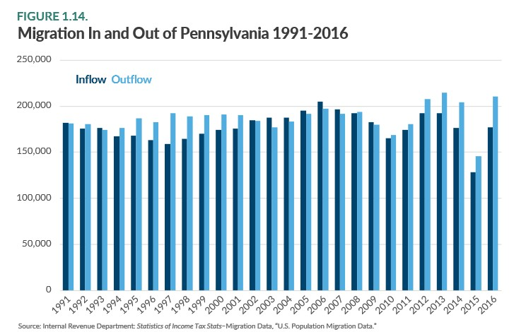

What is driving this? From the 20,000 foot view it is lack of opportunity and high tax burden.

Let’s drill down a bit. First we will discuss our brain drain issue. Pennsylvania’s colleges and universities are highly respected nationwide and continue to draw both in state and out of state talent. Due to our unfriendly business environment, there is little opportunity for our graduates. Many vacate the state for business friendly states where opportunity abounds. We educate, they leave.

Second is our high tax burden, Gallup found that higher tax burdens translate into the desire to leave the state. It is well documented by the PA IFO that Pennsylvania’s property taxes are placing an undue burden on property owners. This chart (Figure 4.1) provided by the PA IFO, which can be found in their analysis of SB76, clearly shows that school district property taxes are rising far faster than inflation or average weekly wages. The trend since 2012-13 has NOT abated.

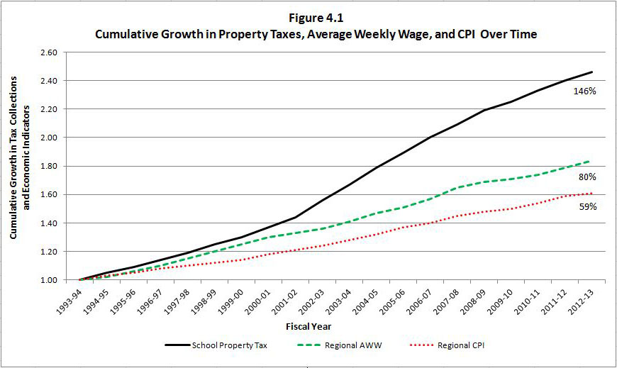

By keeping our educated student graduates in Pennsylvania, high tech industry will look very closely at our state. High tech companies, clearly the present and the future, look for an educated workforce. Literally all business has integrated some form of high tech into their process. Thus, they look for states where there is an ample supply of educated individuals. Add NO property tax to the mix and Pennsylvania will become extremely attractive to businesses, the complete opposite of the current environment.

Our high tax burden, specifically, our ever rising property taxes, are driving those of all ages out of the state. The burden is perhaps the hardest on fixed income elderly folks. It is much harder for the elderly to pick up their roots and move. Many simply do not have the funds to make such a move. Many feel trapped, distraught, and betrayed by failed Government promises and programs. It must be extremely daunting for these individuals to contemplate moving out of state perhaps leaving family and a support system behind.

Home ownership is out of reach for many younger folks and a high tax burden is driving many home owners on fixed income into tax sales or foreclosures. Folks of all ages are being forced to set their sites outside our state contributing to our out-migration trend.

As with many of Pennsylvania’s ills, enacting HB/SB76 would reverse both of these trends contributing to the self-perpetuating upward financial spiral.

- Let’s look at community blight, a huge problem in Pennsylvania. What would eliminating property taxes do to improve this situation? This is most likely the single most powerful tool that could be implemented to battle community blight. Property owners would have more cash in their pocket to maintain properties. Landlords would be much less likely to ignore code violations and most would do a better job of keeping properties in good repair. Homeowners would do the same and much more, many would employ contractors for long desired improvements or additions that were not pursued due to property tax impact. Others would upgrade to a new home. Contractors, realtors, and all related business would see a boon in their demand all contributing to the self-perpetuating upward financial spiral.

- Many claim the bill would hurt low income individuals and families. This is a very short term myopic view; in reality the bill would create opportunity for the lower income. First, the bill protects low income folks by not taxing WIC items. Clothing under $50.00 would not be taxed. Beyond this, with a much improved job environment, many low income or unemployed will be able to improve their financial situations by finding employment or through improved advancement opportunity. Within this group are many who are currently unable to afford a home purchase. For several, this would change which would drive the demand for realtors, contractors, Big-Box stores, and Mom and Pop stores. Once again there is that common undeniable theme, all contributing to the self-perpetuating upward financial spiral.

Associated with this claim is wealthy land barons are the individuals who would benefit. Many in this classification have taken advantage of “Clean & Green”. This program is a land conservation program that lowers the property tax rate for those enrolled in the program. Enrolling in the program cuts property taxes in half on average and sometimes far more.

- Let’s take a look at folks who rent. Renters DO pay property taxes via their rent. It is estimated to be roughly 12% of their rent. Thus, if their rent is $1000 / month they are indirectly paying roughly $1440 annually to cover property taxes. Due to the rapidly rising nature of property taxes, landlords are being forced to pass annual hikes along to the renter. Rental occupancy is at near all time highs and homeownership at lows. By eliminating property taxes the huge pent up glut of renters who desire to purchase a home would be unleashed. Within a short period of time landlords will have trouble finding renters. This will almost assuredly lead to downward pressure on rental rates. At the very least, rental rates will stabilize for many years. Market forces always win in the end. It is conceivable that some landlords would convert their rental properties to owner occupied homes due to the demand for owner occupied homes. This captures many positives already discussed; increased demand for housing and all associated supporting business, and combats community blight. At the risk of being repetitive all contributing to the self-perpetuating upward financial spiral.

- This is an important point that few understand. The PA IFO, though historical analysis, has found that SUT and PIT rise intrinsically on a yearly basis. This is driven by increasing wages and product cost. Average annual SUT and PIT revenue increases are more than enough to fund schools as defined by HB/SB 76. The bottom line is there would be no need to annually increase SUT and PIT to fund schools. SUT and PIT are modified in terms of decades, whereas property taxes rise every year. Clearly a HUGE positive.

- Although we pledged nothing but positives, we will mention one example of a naysayer’s position and how what they perceive as a negative, in reality, is a positive. This can be applied across the board and is an example of pervasive myopic thinking. Many newspapers are against HB/SB 76 because papers would be taxed under the bill. This position is born out of naivety. Their narrow-minded concern is falsely based on how this would impact their business. What many fail to understand is the big picture. With the passing of HB/SB 76, a vast majority of Pennsylvania’s citizens will have more spendable cash, thus, being able to afford products and services such as a paper subscription driving demand up, not down. Apply this across the board and significantly increased demand will contribute to the self-perpetuating upward financial spiral.

- A school districts number one concern is the student, of this we have no doubt. Along this line of thinking is a well known quote, “Education Begins at Home”. For this to occur, it is imperative that the home environment be as stable as possible. High tax burdens have shaken the financial stability of many homes and the souls in those homes in many ways. The result is parents working longer hours if available, more than one job, lowering thermostats, fast food diners, marital stress, and children spending more time without parental involvement. How can parents effectively interact with their children when absent, stressed, or exhausted? A stable home environment for children is perhaps the single most important social improvement of enacting HB/SB 76. A reduced stress home benefits the student, the school, and the parents work productivity which in turn contributes to the self-perpetuating upward financial spiral.
In closing we hope you have gained a more comprehensive understanding of the many positive impacts that go well beyond the signatures that would enact the bill. Through a significantly improved business environment and a huge cash injection into the economy, the inescapable forces that would drive the self-perpetuating upward financial and social spiral have been quantified and the dots connected.
Pennsylvania Taxpayers Cyber Coalition,
Robert Kistler
David Baldinger
Brian Fake

